

BRAC UNIVERSITY

CSE461: Introduction to Robotics

Lab Project Report
Title: SmartSort: AI-Based Automatic Waste Segregation Robot
by
Group 3
Section 4
Group Members:
Name | ID
M. Aliul Siddique Antor | 21301633
Mihir Das | 22299480
Fariaa Afroz Esha | 22201530
Farhan Zarif | 23301692
Hirok Roy Rahul | 22299082
Department of Computer Science and Engineering
BRAC University
August 29, 2026

Abstract
SmartSort is an autonomous waste segregation robot that is small, compact and self-contained, and is suitable for segregation at source level between biodegradable waste and recyclable/non-biodegradable waste. The updated implementation uses an ESP32-S3 camera module for image capture and on-board CNN classification, and an Arduino Nano with a PCA9685 PWM servo driver for sensor reading and actuator control. An item detected by the IR sensor array is captured in a controlled environment, classified locally, and delivered to the appropriate pile or compartment by means of a servo-controlled arm and gripper. Fill level is monitored by ultrasonic sensing, while buzzer/LED alerts and the local web dashboard communicate full-bin, sorting, and uncertain-classification states. The project fills the gap of the lack of source segregation in Dhaka and presents how embedded machine learning, microcontroller interfacing and robotic actuation can help achieve a meaningful and viable sustainable goal.

Keywords
Embedded systems; waste segregation; ESP32-S3; Arduino Nano; computer vision; robotic arm; web dashboard; sustainability

1. Introduction
Recycling or composting municipal solid waste is more challenging when organic and inorganic materials are present at the source. The project plan states that Dhaka produces 6,500 tonnes of MSW daily, of which 70–80% is organic. However, it is not always guaranteed that sources are appropriately segregated in homes, dorms, university corridors, and tiny offices; as a result, recycled material is occasionally combined with other materials that are dumped in landfills.
The goal of SmartSort is to develop and evaluate an autonomous robot that identifies a trash item, takes a picture of it, determines whether or not it is biodegradable, and physically sorts it without the use of a remote control. The system is designed for a controlled demonstration configuration that enables the use of a single light weight at a time, a fixed camera location, a stable light source setup, and predetermined arm positions.
As the project requires sensors, embedded image processing, UART communication between the ESP32-S3 and Arduino Nano, PWM-based servo control through a servo driver, regulated power supply, and feedback through buzzer, LED, and dashboard modules, it is relevant to computer interfacing.

2. Related Work/ Inspiration
Some current smart-bin technologies use proximity sensors to trigger a lid opening or ultrasonic sensors to measure fill level. For a small course prototype, industrial waste-sorting systems might be employed using conveyors, larger cameras and external processing, but these are not cost-effective and would not work well for a small prototype. SmartSort is based on those systems but is built for a small, local, inexpensive system.
The key aspect of this project is the complete perception-decision-actuation loop. The ESP32-S3 performs local image classification, the Arduino Nano controls the sensors and servos, and the arm and gripper are responsible for the physical sorting action. Instructor feedback also influenced the final direction, focusing on a repeatable pick-and-place demonstration - two object classes, simple lightweight objects, predetermined arm positions, and full-bin or error notification behavior.

3. Technical Approach
The four major layers of the system are: Sensing, Classification, Control, and Actuation. In the IR sensing stage, a 5-array IR panel detects the presence of an item. The Arduino Nano then sends a trigger packet to the ESP32-S3, which captures images and runs the Edge Impulse CNN/FOMO model. The classification result is returned to the Nano with a verdict for green/biodegradable, red/recyclable, or empty/uncertain. The Nano controls the servo motors of the base, arm, elbow, gripper, and bin latches, while ultrasonic sensors monitor the fill level of both bins. The workflow is: detect item, trigger vision sampling, classify image, check bin capacity, execute pick-and-place motion, confirm completion, and return to standby.
Components: ESP32-S3 camera module, Arduino Nano, PCA9685 PWM servo driver, servo motors for base/arm/elbow/gripper/latch control, HC-SR04 ultrasonic sensors, 5-array IR panel sensor, buzzer module, LED module, regulated 5 V power supply, jumper wires, breadboard, and a plywood or acrylic chassis. Arduino IDE is used for microcontroller programming, and Edge Impulse/TensorFlow Lite Micro is used to train and deploy the compact image-classification model.

Component | Unit Cost (Tk.) | Quantity | Total (Tk.)
ESP32-S3 camera module | 940 | 1 | 940
Arduino Nano | 939 | 1 | 939
MG90S / micro servo motors | 180 | 2 | 360
Ultrasonic sensor (HC-SR04) | 125 | 2 | 250
IR proximity sensor / IR array | 70 | 1 | 70
5 V exhaust fan or auxiliary airflow module | 150 | 1 | 150
White LED ring or strip | 60 | 1 | 60
Buzzer and LED module | 30 | 1 | 30
18650 battery pack and charging module | 300 | 1 | 300
5 V / 2 A buck converter | 120 | 1 | 120
Acrylic/plywood chassis and compartments | 1,200 | 1 | 1,200
Jumper wires and breadboard | 350 | 1 | 350
Miscellaneous screws, glue, wiring, resistors, capacitors | 700 | 1 | 700
Estimated Total |  |  | 5,469
Estimated Total Cost: Based on the original proposal's component list, the approximate project cost is Tk. 5,469. The main cost contributors are the chassis and bin compartments, camera/controller hardware, servo mechanisms, wiring, mounting materials, and regulated power components.
Circuit/Schematic: The final wiring uses an Arduino Nano as the main controller. The 5-array IR panel is connected to D8-D12. The left/red ultrasonic sensor uses D2 as Trig and D3 as Echo, while the right/green ultrasonic sensor uses D4 as Trig and D5 as Echo. ESP32-S3 communication uses Nano D6/D7 with ESP32 GPIO 2/GPIO 1 over UART. The PCA9685 servo driver maps CH0 to the red/left bin latch, CH12 to the green/right bin latch, CH4 to the base, CH10 to the arm, CH11 to the elbow, and CH1 to the gripper. A common ground and stable regulated 5 V supply are required because camera capture and servo movement can create sudden current demand.
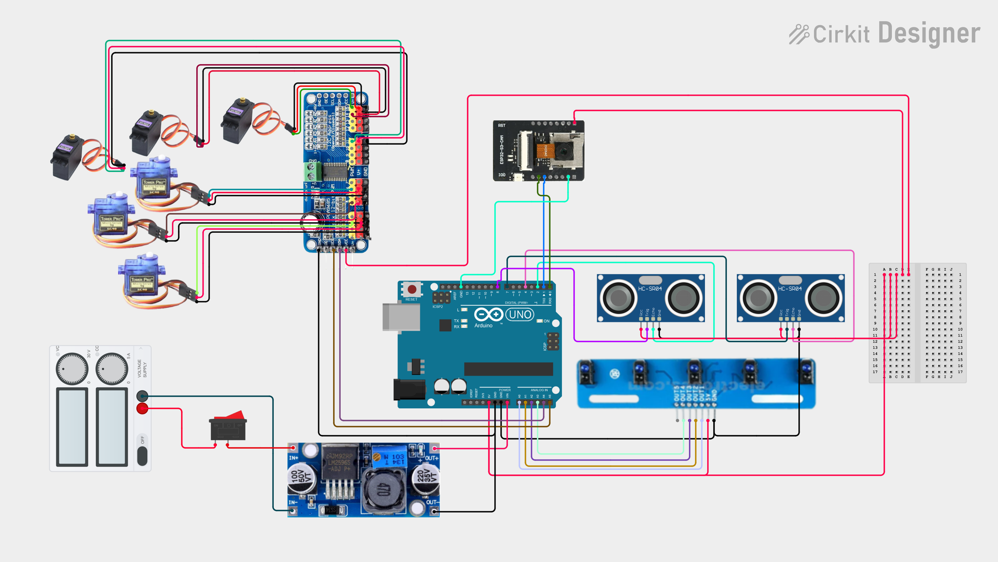

Figure 1. SmartSort control circuit schematic.
Web Dashboard: The ESP32-S3 hosts a local dashboard that displays the current system state, latest verdict, red/green bin-level telemetry, event log, and full-bin handling controls. The dashboard states include standby, sampling, sorting, fault, green-bin-full, and red-bin-full. This gives the project a visible monitoring interface without changing the autonomous sorting sequence.
Functionality: In operation, the Arduino Nano stays in an idle state while streaming ultrasonic telemetry to the ESP32-S3 dashboard. When the IR array detects an object, the Nano sends a D trigger to start a 5-second vision-sampling window on the ESP32-S3. The classifier returns G for biodegradable/green, R for recyclable/red, or E for empty/uncertain. Before moving the arm, the Nano checks the target bin using ultrasonic sampling; if the distance remains at or below 3.0 cm for the verification period, it blocks arm motion and sends a full-bin alert. If capacity is available, the arm opens the gripper, moves to the pickup pose, grips the item, lifts, rotates the base to the target bin angle, releases the object, and returns home. The ESP32-S3 receives K when sorting is complete and can display the current state on the web dashboard.
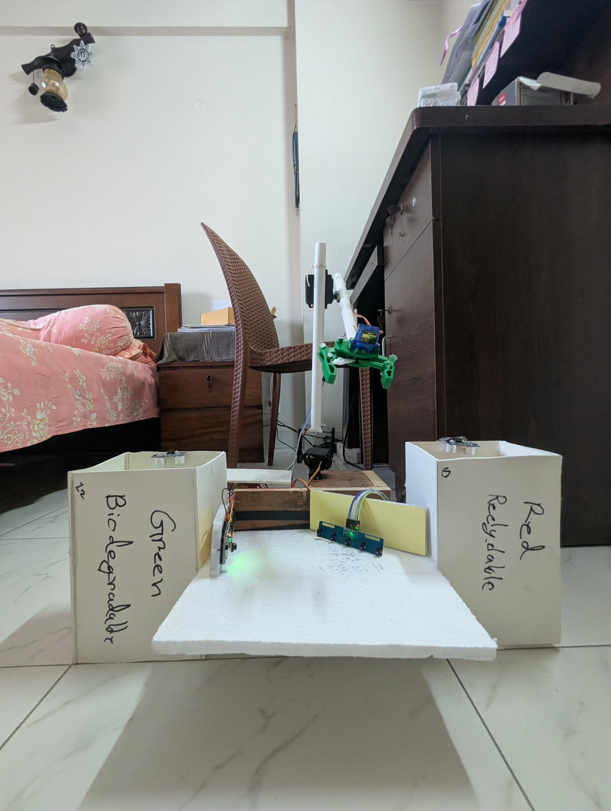
Figure 2. Final SmartSort prototype with arm, gripper, and two labeled bins.
Challenges: The main risks are ESP32-S3 memory allocation issues during Edge Impulse inference, power instability during camera capture and servo motion, servo stall or object slip during pickup, inconsistent classification due to lighting changes, ultrasonic noise near the bin threshold, and UART packet timing between the two controllers. These are addressed through TensorFlow Lite Micro arena adjustment, use of PSRAM/aligned allocation, a regulated 5 V supply, common grounding, fixed lighting and background, predefined lightweight test objects, a 5-second bin-full verification window, and simple UART command packets.

4. Sustainability & Impact
Sustainability: SmartSort contributes to environmental sustainability by separating waste before recyclables and biodegradable materials become polluted. The energy is little because it is a low voltage electronics design that just needs energy for sorting. For the chassis, think of using acrylic or plywood. Individual electronic components can be fixed, reused, or changed without throwing away the system as a whole.
Benefit: By reducing manual trash management and promoting source separation, the project will assist homes, dorms, colleges, and small offices. Additionally, rather than being only a classroom demonstration, it shows users and students how robotics may be directly applied to a community sustainability issue.
Future Work: Future development should expand the training image collection, strengthen the arm and gripper, improve dashboard logging and data export, make the bin-clearing mechanism more dependable, and test the system with a wider range of object sizes after the current pick-and-place sequence remains consistent.
Limitations: As of right now, the prototype can only handle one lightweight object at a time. It depends on repeatable object shapes, controlled lighting, a predetermined camera position, and a trained item set. It is currently unsuitable for outdoor environments and heavy, wet, or industrial trash.

5. Results & Discussion
The updated project materials include implementation code, dashboard screenshots, a trained model result, pin layout, and demonstration notes. Final testing should still use repeated trials with real test objects. The most important metrics are classification accuracy, physical routing correctness, cycle duration, fill-level alert reliability, pickup dependability, and power stability.
The Edge Impulse validation screenshot reports an F1 score of 100.0% on the validation set for the controlled classes, with about 895 ms inferencing time, 133.0 KB peak RAM usage, and 81.3 KB flash usage. The earlier proposal target was at least 85% binary classification accuracy, while the instructor feedback recommended aiming for at least 95% in the controlled final demonstration. The motion target remains 5 seconds or less per sorting cycle, and the bin-full logic verifies a 3.0 cm threshold for 5 seconds before sending a full-bin alert.
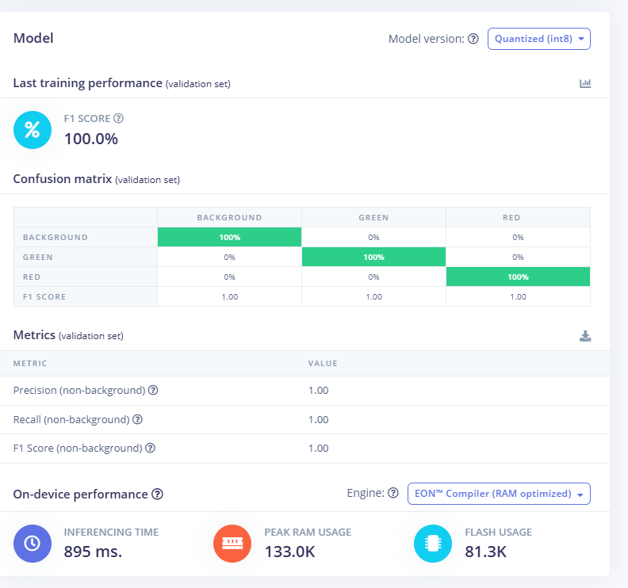
Figure 3. Edge Impulse validation result for the controlled image-classification model.
Moreover, there are design tradeoffs between recognition breadth and mechanical dependability. A broad open-world classifier would make the project seem more general, but it would also make the final presentation harder to prove. The implemented state machine makes the demonstration clearer: the robot detects an item, samples vision for 5 seconds, receives a verdict, checks bin capacity, sorts only when safe, reports full-bin states, handles object-removal faults, and resets without remote control.

6. Conclusion
SmartSort is an autonomous waste segregation system that integrates sensors, embedded image categorisation, actuator control, web-based telemetry, and user feedback. The ESP32-S3 provides the vision and dashboard layer, the Arduino Nano serves as the sensor and servo-driven actuation controller, and the robotic arm performs the visible sorting function. The design works best in a controlled source-level setting where the number of lightweight objects and pick-and-place poses is limited.
The research is significant because it links robotics theory to a practical environmental issue. In addition to increasing valuable material recovery and lowering the danger of handling contamination, SmartSort can show the importance of computer interfacing in creating an environmental tool.

7. Contribution
Name | ID | Role(s) / Responsibilities | Specific Contributions

References
Arduino. (n.d.). Arduino Nano documentation. Arduino Documentation.
BRAC University. (2026). CSE461 lab project poster guidelines. Course material.
Edge Impulse. (n.d.). Edge Impulse documentation. https://docs.edgeimpulse.com/
Group 3. (2026). SmartSort: AI-based automatic waste segregation robot project proposal. CSE461: Introduction to Robotics, BRAC University.
Group 3. (2026). Project code and implementation notes for SmartSort. CSE461: Introduction to Robotics, BRAC University.
Google. (n.d.). TensorFlow Lite for Microcontrollers. https://www.tensorflow.org/lite/microcontrollers

